**Steps to download Pinnacle 21 Community Tool**

Pinnacle Community 21, formerly known as OpenCDISC, is an SDTM validation tool used by the FDA to validate SDTM submissions via the FDA Gateway.

1. Go to the following URL and download the Pinnacle 21 Community, windows version,

<https://www.pinnacle21.com/downloads>

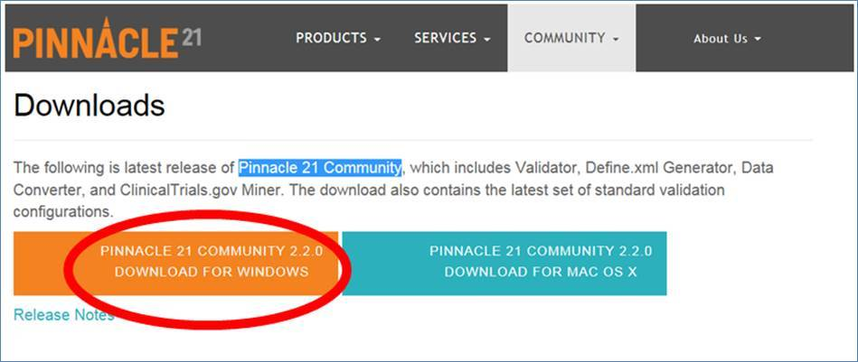

1. Unzip the downloaded file in its own directory.

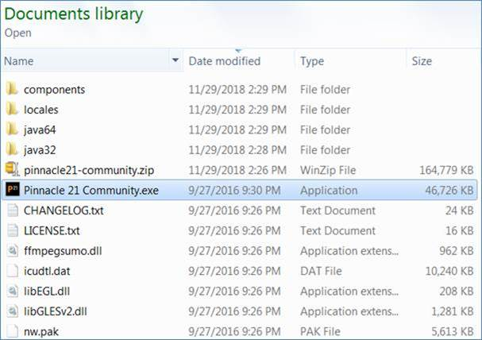

1. Run the “Pinnacle 21 Community.exe” file

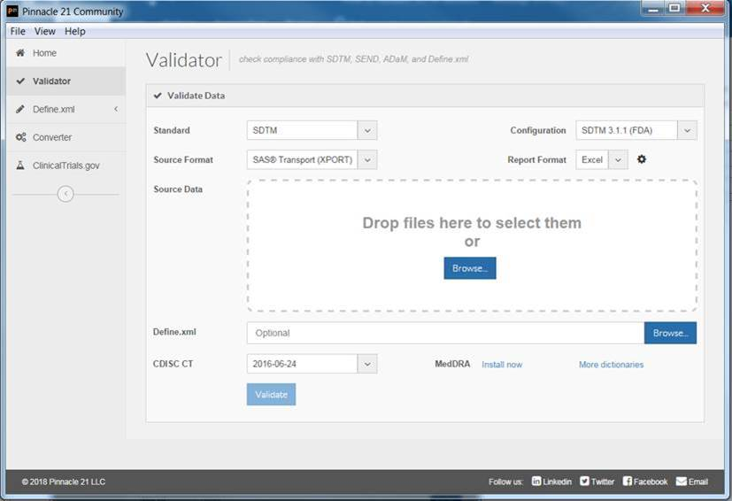

1. Drag and drop the .xpt SDTM files in the designated area in the UI and click validate.
2. Drop the Once the validation is completed, an Excel file will be created in the shown directory which contains the validation results

